PRESS RELEASE: FOR IMMEDIATE RELEASE

NORTHLAND BARBERSHOP CHORUS PRESENTS 49th ANNUAL SHOW:

“KING OF THE ROAD”

AN ADAPTATION OF THE O. HENRY SHORT STORY:

“THE COP & THE ANTHEM”

The NORTHLAND BARBERSHOP CHORUS of the Sault, Ontario Chapter of the Barbershop Harmony Society is proud to announce its 49th Annual Show will be presented Sat. April 06th, 2013 starting at 7:30 p.m. at the Kiwanis Community Theatre Centre.

BACKGROUND: O. HENRY and “The Cop and the Anthem”
William Sydney Porter (1862 – 1910), better known by his pen name O. Henry, was an American writer whose stories are known for their wit, wordplay and clever twist endings. Many of his stories take place in New York City and often deal with ordinary people: clerks, policemen, waitresses and, in this case, hobos. Perhaps his best known story is “The Gift of the Magi”.

In December 1904, the newspaper New York World published O. Henry’s “The Cop and the Anthem", a short story about a hobo named “Soapy”. It included several of the classic elements of an O. Henry story: a setting in New York City, an empathetic look at a member of the lower class, and an ironic ending.

With winter approaching, Soapy sets out to get arrested so that he can be a guest of the city jail for a few months instead of sleeping out in the cold. However, every action that he takes creates a reaction opposite to the one he wishes. Despite efforts at petty theft, vandalism, disorderly conduct, and "mashing" with a woman he meets in the park, Soapy fails to draw the attention of the police. Thus, Soapy seems a man “doomed to liberty.”

The use of dramatic irony is an O. Henry trademark. The irony here is that as long as Soapy is “free,” that is, loose in the city, he is not free at all, because of the coming winter. If he were in prison, however, he would indeed be “free” to enjoy life without fear of the elements. O. Henry goes on to furnish a skillful and ironic twist ending for our enterprising hobo.

SHOW DETAILS
The 40+ man chorus will present songs in traditional four-part barbershop harmony within the context of an adaptation of O. Henry’s original 1904 story, written by chorus member Bob Shami. The setting is a park bench in a big city park. The central character is a gentleman hobo named Soapy, who along with Hollis, his younger hobo apprentice, is determined to find a way to stay warm through the coming winter despite being broke. While Hollis muses about hopping a train to Florida, Soapy will have none of that. After spending a cold autumn night on the park bench, Soapy sets about trying to get arrested so that he might spend the coming winter in the relative comfort of a jail cell at the city’s expense. He finds it is not as easy a task as he imagines!
The cast of the show includes several local theatre veterans: Harry Houston as Soapy, Anthony Aceti as his sidekick Hollis, Vernon Bailey as the Cop, and Terri Miller appears in two cameo roles.
FEATURED MUSICAL PERFOMERS
- NORTHLAND BARBERSHOP CHORUS: Now in their 52nd year. Bob Shami – Music Director
- HEADLINE QUARTET – ‘ROUND MIDNIGHT: World Class Barbershop Quartet from New York City. This quartet is comprised of 4 young men who are rising stars in the barbershop community; all four hold degrees in music and are employed as music educators.

All Tickets: General Admission – $25.00* CDN or US Funds, available at:
- Theatre Centre Box Office* (Station Mall) Hess Jewellers (Churchill Plaza)
- Any member of the Northland Chorus LPL Financial Services (812 Ashmun St. Soo, Mich.)
- Tickets may also be available at the door. Doors open at 6:45 p.m. Curtain is 7:30 p.m.

* A $3.00 per ticket service charge is added by the Station Mall Box Office to all tickets they sell. Box Office price is $25.00 + $3.00 = $28.00 total.

As always, a major portion of the proceeds will go to support local speech therapy programs at the Speech-Language Pathology Unit of the Sault Area Hospital. More than $65,000 has been donated by the Northland Chorus to this cause since 1995 in keeping with their motto:

“We Sing … That They Shall Speak.”

Northland Chorus - General Information

Barbershop singing had its beginnings in American barbershops of the 1890’s through 1920’s. Barbershops served as “tonsorial parlours”: places where men gathered to share news, camaraderie and a song or two.
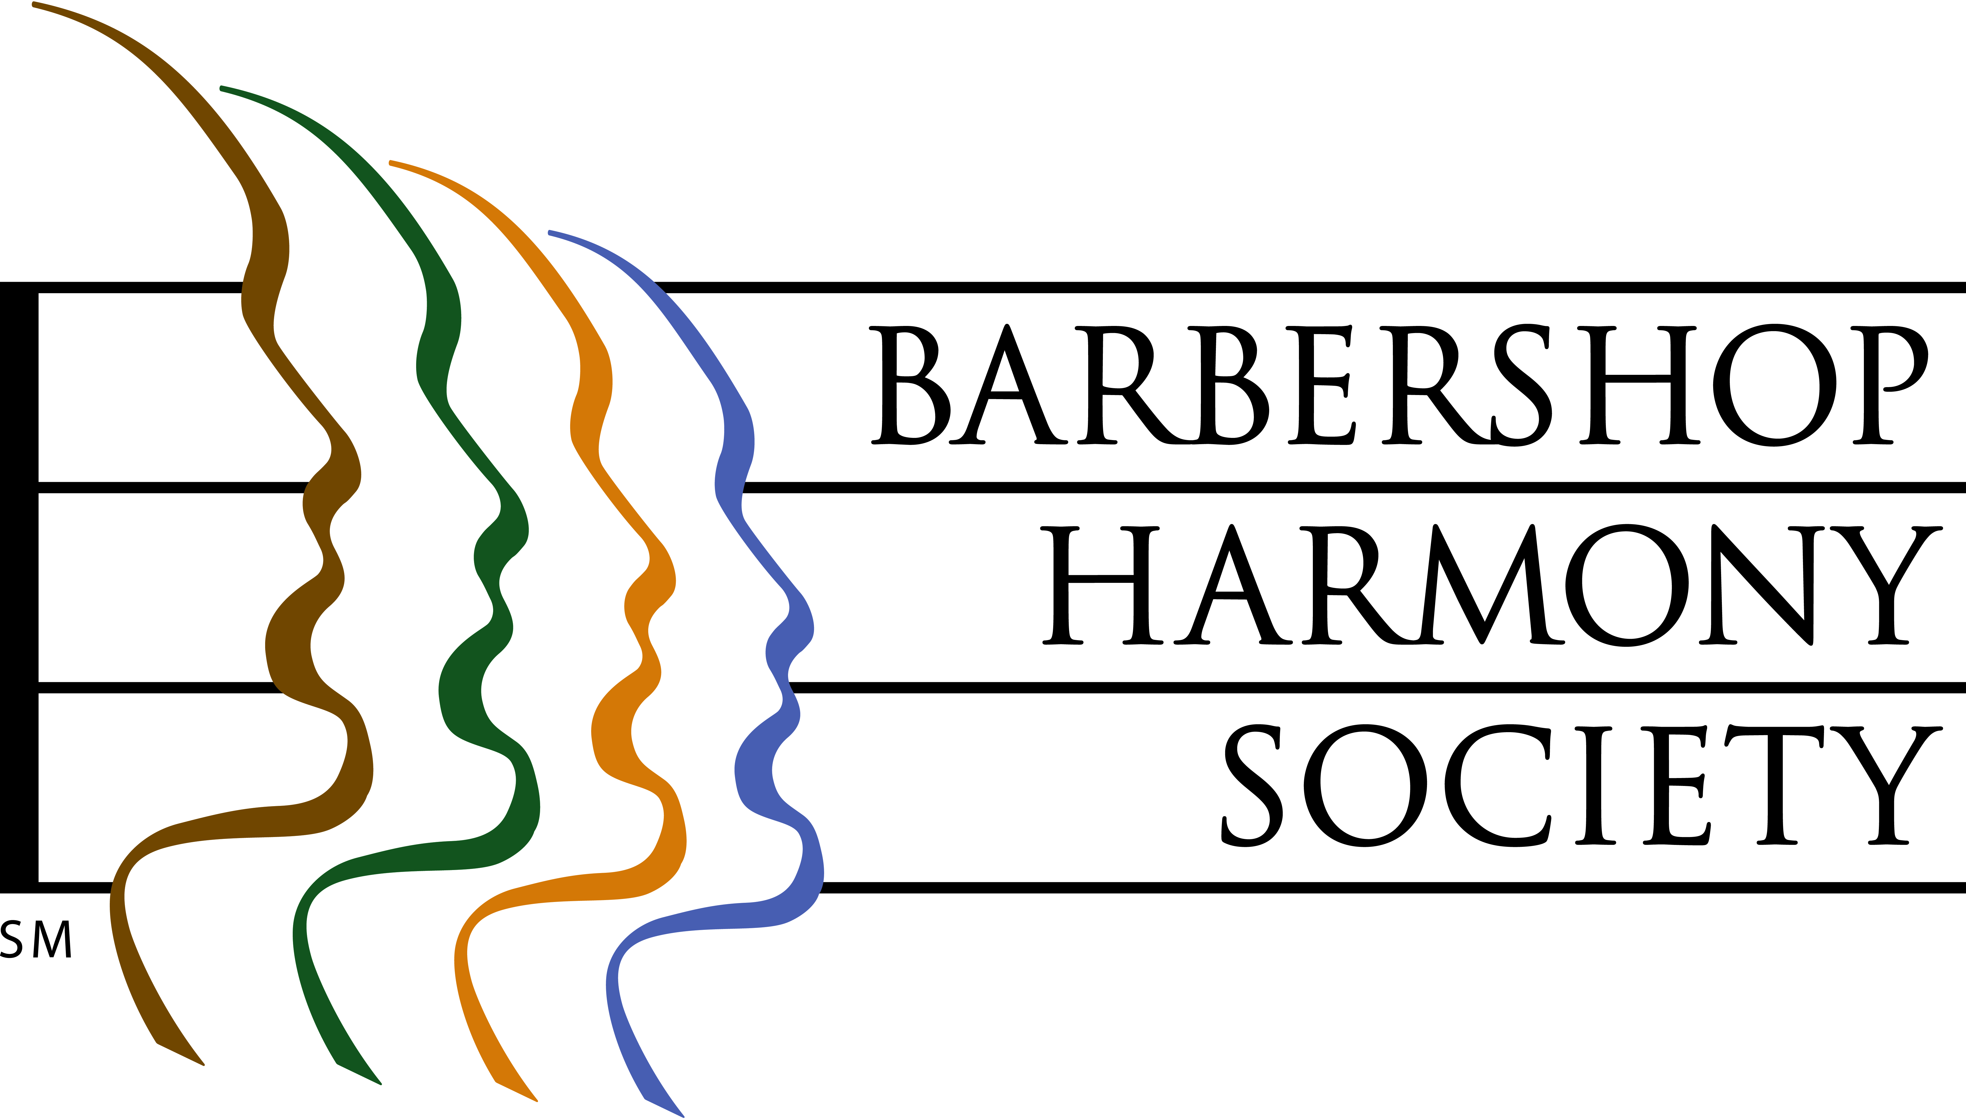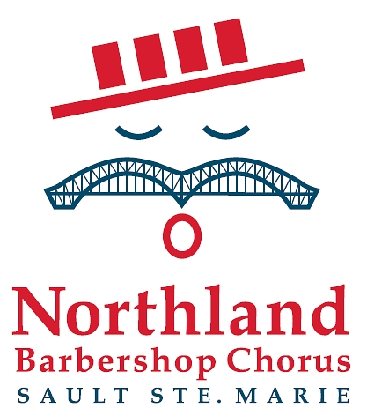

At left, the logo of the Barbershop Harmony Society, an umbrella international organization which serves 30,000+ members in 800+ chapters across North America. It granted the Sault Chapter its charter in 1961.

At right, the logo of the Sault Ste Marie Chapter of the Barbershop Harmony Society. It represents an iconic barbershop singer whose International Bridge/handlebar moustache is symbolic of our membership coming from both sides of the border. The red, white and blue colours represent the colours of the flags of both nations. The four bars in the hat represent the 4-part harmony that is the hallmark of the barbershop style, and recall the stripes of a traditional barber pole. The “oh” vowel being sung is the first sound in each country’s national anthem.

Northland Chorus - 2010 Medal of Merit Winner

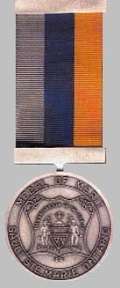

The City of Sault Ste Marie awarded the Northland Barbershop Chorus the 2010 Medal of Merit, the city’s most prestigious honor, in recognition of community service given over 5 decades. The award is given to nominees who are recognized for “outstanding achievement in a chosen area which has resulted in making a valuable contribution to the community”. The award was officially presented to all then-currently active chorus members by Mayor Debbie Amoroso at a civic ceremony and dinner held May 7, 2011.
__________________________________________________________________________________________


Northland Barbershop Chorus 49th Annual Show, April 6th, 2013
“KING OF THE ROAD”

Bob Shami: Music Director and Publicity Chairman
Home Phone: (705)-253-9574
Cell Phone: (705)-254-9368 E-mail: bshami@shaw.ca
For Ticket Information
In Canada, Doug Iles at (705)-942-3075
In US, Don Myers at (906)-635-8772

