PRESS RELEASE: FOR IMMEDIATE RELEASE

NORTHLAND BARBERSHOP CHORUS PRESENTS 48th ANNUAL SHOW:

“DIRE DAYS AT THE DAIRY”

OR

‘UDDER’ MAYHEM”
~A BARBERSHOP MELODRAMA~

The NORTHLAND BARBERSHOP CHORUS of the Sault, Ontario Chapter of the Barbershop Harmony Society is proud to announce its 48th Annual Show will be presented Sat. April 14th, 2012 starting at 7:30 p.m. at the Kiwanis Community Theatre Centre.

BACKGROUND: THE MELODRAMA
With 2012 being the 100th Anniversary of the City of Sault Ste Marie, this show is a tribute to a style of theatre that was popular 100 years ago when the Sault was new: the melodrama! Set on a dairy farm in Bar River, this old-fashioned melodrama was written by chorus members Bob Shami and Stephen Patterson. Theatrical melodramas were most popular from the late 1800's until the silent film era of the late 1910’s.

The word "melodrama" comes from "melos", the Greek word for music, combined with "drama". Melodramas were traditionally performed with live orchestral or vocal music accompanying the action. The Victorian stage melodrama featured stock characters such as: the hero, the sidekick, the villain, the heroine, the aged parent. Often the hero was duped by a scheming, black-caped villain who menaced the damsel and her widowed parent whilst twirling his long moustache in evil glee. Then, when all hope seemed lost, virtue overcame vice. Happy endings were assured! It remains great family entertainment and the essence of bringing community to theatre.

Melodramas are still characterized by acting which incorporates large gestures and lavish facial expressions, an acting style once necessary so that people sitting in the backs of theatres could follow the action. Today the acting is kept that way just because it's more fun!

Modern melodramas are still about having fun and are never intended as passive entertainment. The audience is encouraged to show their displeasure by booing the heartless villain and their delight by cheering the sweet damsel in distress and her brave hero as good triumphs over evil.

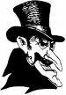
SHOW DETAILS
The 50+ man chorus will present songs in traditional four-part barbershop harmony within the context of an original play. The setting is a struggling family dairy farm in Bar River, ON, with local references and dairy puns the order of the day. The standard melodrama characters include: the hero, dairyman Beau Vine (Stephen Patterson), his dim friend Mookie Whey (Kevin Collar), the woeful widow Elsie-Sue MacDonald (Terri Miller), her sweet daughter Beatrice (Jaime Miller), and of course, the nasty villain Dr. Salvatore Monella (Chas Calam). Susan Barber will provide piano accompaniment. With audience boos, hisses and cheers, an experienced cast and great barbershop harmony, the result should be ‘udder’ mayhem.
FEATURED MUSICAL PERFOMERS
- NORTHLAND BARBERSHOP CHORUS: Now in their 51st year. Bob Shami – Music Director
- HEADLINE QUARTET – CROSSROADS: World Class Barbershop Quartet Champions from St. Louis, MO, and Ft. Myers, FL, named 2009 International Champion Quartet. This quartet is comprised of 4 men who are legendary figures in the barbershop community; all have previously won championship gold medals with other top quartets.

All Tickets: General Admission – $25.00* CDN or US Funds, available at:
- Theatre Centre Box Office* (Station Mall) Hess Jewellers (Churchill Plaza)
- Any member of the Northland Chorus LPL Financial Services (812 Ashmun St. Soo, Mich.)
- Tickets may also be available at the door. Doors open at 6:45 p.m. Curtain is 7:30 p.m.

* A $3.00 per ticket service charge is added by the Station Mall Box Office to all tickets they sell. Box Office price is $25.00 + $3.00 = $28.00 total.

As always, a major portion of the proceeds will go to support local speech therapy programs at the Speech-Language Pathology Unit of the Sault Area Hospital. More than $60,000 has been donated by the Northland Chorus to this cause since 1995 in keeping with their motto:

“We Sing … That They Shall Speak.”

Northland Chorus - General Information
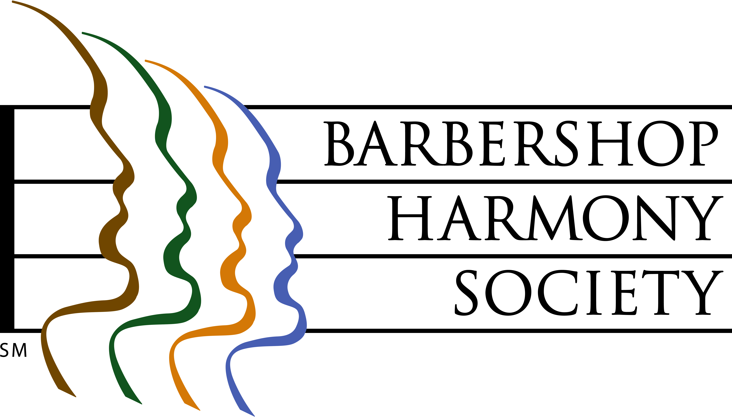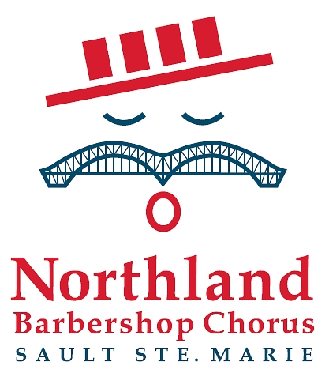
Barbershop singing had its beginnings in American barbershops of the 1890’s through 1920’s, and their role as “tonsorial parlours”, places where men gathered to share news, camaraderie and a song or two.

At left, the logo of the Barbershop Harmony Society, an umbrella international organization which serves 30,000+ members in 800+ chapters across North America. It granted the Sault Chapter its charter in 1961.

At right, the logo of the Sault Ste Marie Chapter of the Barbershop Harmony Society. It represents an iconic barbershop singer whose International Bridge/handlebar moustache is symbolic of our membership coming from both sides of the border. The red, white and blue colours represent the colours of the flags of both nations. The four bars in the hat represent the 4-part harmony that is the hallmark of the barbershop style, and recall the stripes of a traditional barber pole. The “oh” vowel being sung is the first sound in each country’s national anthem.

Northland Chorus - 2010 Medal of Merit Winner

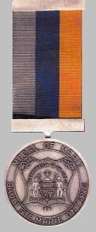

The City of Sault Ste Marie awarded the Northland Barbershop Chorus the 2010 Medal of Merit, the city’s most prestigious honor, in recognition of community service given over 5 decades. The award is given to nominees who are recognized for “outstanding achievement in a chosen area which has resulted in making a valuable contribution to the community”. The award was officially presented to all then-currently active chorus members by Mayor Debbie Amoroso at a civic ceremony and dinner held May 7, 2011.
__________________________________________________________________________________________


Northland Barbershop Chorus 48th Annual Show, April 14, 2012
“DIRE DAYS AT THE DAIRY or ‘UDDER’ MAYHEM”

Bob Shami: Music Director and Publicity Chairman
Home Phone: (705)-253-9574
Cell Phone: (705)-254-9368 E-mail: bshami@shaw.ca
For Ticket Information
In Canada, Doug Iles at (705)-942-3075
In US, Jim Schmidt at (906)-632-3640

