PRESS RELEASE: FOR IMMEDIATE RELEASE

NORTHLAND BARBERSHOP CHORUS
PRESENTS 50th ANNIVERSARY SHOW:

SOUND CELEBRATION

~ 50 YEARS OF BARBERSHOP! ~

Come celebrate the sound! The NORTHLAND BARBERSHOP CHORUS of the Sault, Ontario Chapter of the Barbershop Harmony Society is proud to announce its 50th Anniversary Show will be presented Sat. March 26th, 2011 starting at 7:30 p.m. at the Kiwanis Community Theatre Centre.

BACKGROUND – 50 Years of Song in the Sault
On Dec. 1, 1961, the Northland Barbershop Chorus received their official charter to become the Sault Chapter of SPEBSQSA - The Society for the Preservation and Encouragement of Barbershop Quartet Singing in America, Inc. – now the Barbershop Harmony Society, the world’s largest men’s singing organization. Their first performance was in 1962 and a major show has been presented nearly every year since. In 2011, their 50th Anniversary year, the Chorus will present its 47th annual show, titled: “Sound Celebration – 50 Years of Barbershop!”

Over these 50 years, the Chorus and its many quartets have entertained hundreds of audiences in four-part barbershop harmony, here in Sault Ste Marie, in Sault Michigan, and occasionally on the road in towns near and far, serving as musical ambassadors for their hometown and for the music they love.

It has been 50 joyous years of singing at civic events, like the inauguration of a newly-elected City Council, the 1990 Labatt Brier or at Greyhound games; at local music festivals like the Sault Symphony’s Bratwurst, Beer and Beethoven; at churches, schools, hospitals and nursing homes; 50 years of donating performances to help community agencies and charities in their fundraising efforts; 50 years of sharing music with others at life’s most significant events: at weddings, birthdays, retirements, anniversaries, and funerals, including one especially poignant military funeral for a young U.S. Army soldier killed in Afghanistan; 50 years of making regular financial donations to many local agencies until finding a home in 1995 with the Speech Pathology Department of Sault Area Hospital and more recently the War Memorial Hospital in Sault Michigan; most of all, 50 years of brotherhood, making wonderful music together with friends.

In recognition of community service given over 5 decades, the City of Sault Ste Marie has awarded the Northland Barbershop Chorus the 2010 Medal of Merit, the city’s most prestigious honor. The award is given to nominees who are recognized for “outstanding achievement in a chosen area which has resulted in making a valuable contribution to the community”. The award will be officially presented at a civic ceremony in the spring of 2011.
SHOW DETAILS
This will be a concert-style show featuring three musical guests in addition to the Northland Chorus. The concert format represents a change from some of the more theatrical presentations the chorus has produced over the years. Unlike last year’s Western-styled “Horse Opera”, for example, there will be no actual livestock on stage this year! Instead, patrons can expect wall-to-wall singing by a wide array of local and imported a cappella entertainers.

During the Northland Chorus portion of the evening, a wide variety of song types will be presented, illustrating the many different types of songs that can be successfully performed in the barbershop style, from traditional songs most people associate with barbershop (e.g. “Shine On Harvest Moon” - 1905) all the way up to an Elton John song from 1994’s “The Lion King”. The show will feature songs from many eras, from an 19th century traditional hymn, to swing tunes from the 30’s, an Inkspots tune from the 40’s, a Platters tune from the 50’s, Neil Sedaka and Beach Boys tunes from the early 60’s, a Mama Cass Elliot classic from 1968 and more. Four of the arrangements to be performed on this show were written or co-written for the Northland Chorus by their director Bob Shami.

A highlight of the show will be the Chorus’ performance of Shami’s arrangement of the military hymn “Mansions of the Lord”. The original song was written for the 2001 Mel Gibson movie "We Were Soldiers" to honour those who have fallen. It was sung in the movie during the closing credits by the West Point U.S. Military Academy Cadet Glee Club.

The first time the Chorus performed their arrangement of this song in public was at the funeral of a young American soldier at the request of his family. On Nov. 4, 2009, the Chorus was honoured to sing this piece at the full military funeral service held at Sault High for 23 year-old U.S. Army Specialist Brandon Steffey, a native of Sault Ste Marie, Michigan, who was killed in Afghanistan. The song has never before been performed at the annual show. It will be sung at this year’s show in honour of all the men and women of the armed services who have answered the call of their countries, putting themselves in harm’s way for the sake of duty and freedom.
FEATURED MUSICAL PERFOMERS
- NORTHLAND BARBERSHOP CHORUS: Bob Shami – Director
- THE KORAHSTERS: a mixed voice youth choir from Korah Collegiate High School featuring 40-60 singers who take their inspiration from the hugely popular series “Glee”. Ms. Denine Williams – Director
- FEATURED QUARTET – CADENCE: Four men. Four microphones. No instruments. This is the formula for Toronto’s celebrated vocal band, CADENCE, making a return visit to the Sault after being a guest on the Chorus’ 2005 show. With three Juno nominations, and numerous international tours to their credit, CADENCE has earned recognition as “Canada’s premiere jazz-pop a cappella group.” Now in their 10th season of performing contemporary a cappella and surprising audiences with their tight harmony, instrumental imitation, high energy antics and audience interaction.
- HEADLINE QUARTET – VOCAL SPECTRUM: World Class Barbershop! From St. Louis, MO, named 2004 International Collegiate Quartet Champions and 2006 International Barbershop Quartet Contest World Champions. This young quartet sings contemporary barbershop at an incredible skill level.

All Tickets: General Admission – $23.00* CDN or US Funds, available at:
- Theatre Centre Box Office* (Station Mall) Hess Jewellers (Churchill Plaza)
- Any member of the Northland Chorus LPL Financial Services (812 Ashmun St. Soo, Mich.)
- Tickets may also be available at the door. Doors open at 6:45 p.m. Curtain is 7:30 p.m.

* A $2.50 per ticket service charge is added by the Station Mall Box Office to all tickets they sell. Box Office price is $23.00 + $2.50 = $25.50 total.

As always, a major portion of the proceeds will go to support local speech therapy programs at the Speech-Language Pathology Unit of the Sault Area Hospital. More than $55,000 has been donated by the Northland Chorus to this cause since 1995 in keeping with their motto:

“We Sing … That They Shall Speak.”
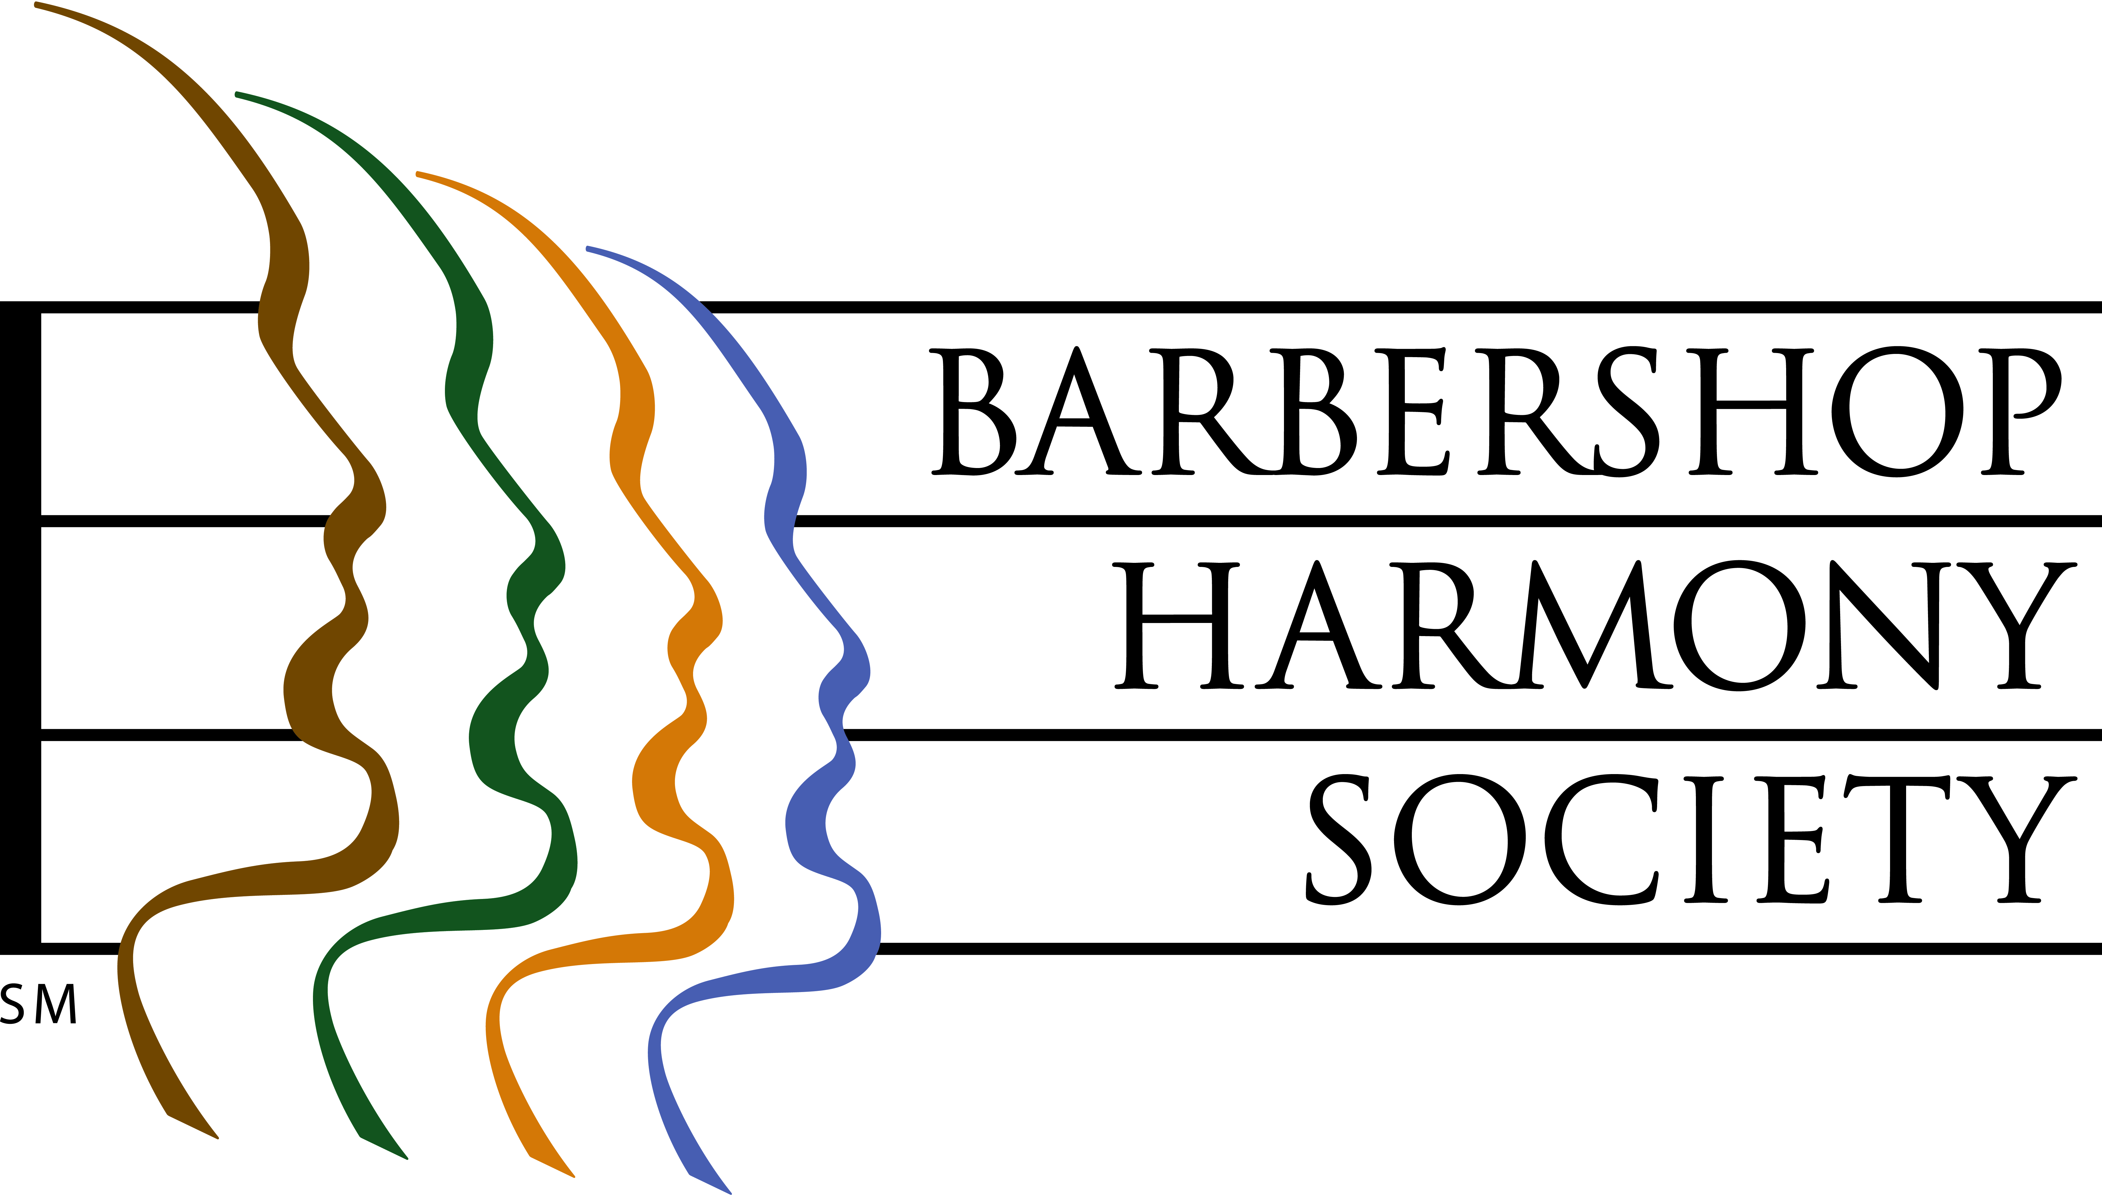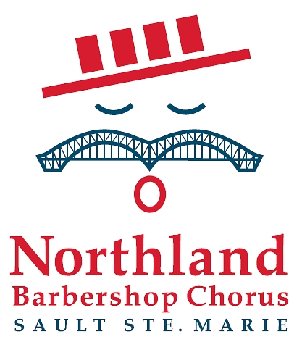
At left, the logo of the Barbershop Harmony Society, an umbrella international organization which serves 30,000+ members in 800+ chapters across North America. It granted the Sault Chapter its charter in 1961.

At right, the logo of the Sault Ste Marie Chapter of the Barbershop Harmony Society. It represents an iconic barbershop singer whose International Bridge/handlebar moustache is symbolic of our membership coming from both sides of the border. The red, white and blue colours represent the colours of the flags of both nations. The four bars in the hat represent the 4-part harmony that is the hallmark of the barbershop style, and recall the stripes of a traditional barber pole. The “oh” vowel being sung is the first sound in each country’s national anthem.

Barbershop singing really can trace its beginnings to American barbershops of the 1890’s through 1920’s, and their role as “tonsorial parlours”, places where men gathered to share news, camaraderie and a song or two.


Northland Barbershop Chorus 50th Anniversary Show, March 26, 2011
“SOUND CELEBRATION – 50 YEARS OF BARBERSHOP”

Bob Shami: Music Director and Publicity Chairman
Home Phone: (705)-253-9574
Cell Phone: (705)-254-9368 E-mail: bshami@shaw.ca
For Ticket Information
In Canada, Doug Iles at (705)-942-3075
In US, Jim Schmidt at (906)-440-7405

