PRESS RELEASE: FOR IMMEDIATE RELEASE

NORTHLAND BARBERSHOP CHORUS
PRESENTS 46TH ANNUAL SHOW:

“COWBOY CHORALE”

~ An Evening of Cowboy Poetry and Western Music in the Barbershop Style ~

The NORTHLAND BARBERSHOP CHORUS of the Sault, Ontario Chapter of the Barbershop Harmony Society is proud to announce its 46TH Annual Show will be presented Sat. April 10TH, 2010 starting at
7:30 p.m. at the Kiwanis Community Theatre Centre.

BACKGROUND
Chorale: [kaw-raal’] “a group of singers specializing in a particular style of music” (Encarta Dictionary)
"The Old West is not a certain place in a certain time; it's a state of mind. It's whatever you want it to be." — Tom Mix
This show combines three genres of performance art into one memorable evening: Classic Western Music sung a cappella in 4-part Barbershop Harmony is featured together with Canadian Cowboy Poetry.
Western Music, often called Cowboy Music, features lyrics that tell a story in the ballad tradition. A common thread in most of the lyrics is the quest for freedom and independence and the willingness to pay the price to live that lifestyle. The pattern of sound of cowboy songs often suggests movement or pace. Listen carefully to a cowboy song and in many instances you will hear the gait of a horse walking, trotting or galloping. The rhythm of a cowboy song is really the rhythm of the cowboy’s natural and working environment.
There are many who feel that Western and Country music are synonymous but they are quite different. Western Music generally has rural content. Most historians suggest that Country music originated in the Eastern United States while Western Music evolved from the life experiences of the western people. [http://www.albertacowboypoetry.com/western_music.htm]
Examples of Western Music that will be performed are: They Call the Wind Mariah, Don’t Fence Me In, Ghost Riders In The Sky, Happy Trails, Home On The Range, Blue Shadows On The Trail and more.
Cowboy Poetry’s popular appeal is probably restricted to the western half of North America, and it begins to appear at a very specific date – not 1870, when this folk art of campfire story-telling first appeared historically – but February of 1985, with the first Cowboy Poetry gathering in Elko, Nevada. It was a huge success, and has been held every year since, making Elko the Nashville of Cowboy Poetry.
So, what is Cowboy Poetry and how can it be recognized? A resolution adopted at the original Elko conference defined it as: “…rhymed, metered verse written by someone who has lived a significant portion of his or her life in Western North American cattle culture. The verse reflects an intimate knowledge of that way of life, and the community from which it maintains itself in tradition...” Cowboy poems function as short stories or parables that reflect and illuminate some aspect of Western rural life. Audiences expect the poem to be heard as a performance, not as a reading from a book. [From: “Cowboy Theatre in Western Canada” by Ken Mitchell]
SHOW DETAILS
"Cowboy Chorale" is a blend of Western Music and authentic Cowboy Poetry presented in the context of an original play written expressly for The Northland Chorus by Western Canadian author, actor, playwright, poet (both Cowboy and otherwise), university English professor and currently, touring performer of cowboy poetry, KEN MITCHELL of Regina, SK. He was awarded the Order of Canada for his work as an "ambassador of Canadian literature at home and abroad." Ken (Chorus Director Bob Shami’s brother-in-law) will be in the Sault to perform in the show along with local theatre community veterans: SUSAN BARBER, AUBREY FALLS AND ED HOUSTON (Harry’s dad!).
PLOT SUMMARY
Act I is set at Gopher Creek Guest Ranch, located in the hills near Moose Jaw, SK, the heart of the Canadian West. A girl from Ontario visits the ranch and falls in love, both with Starbuck, the horse she's been given to ride for the week, and with Big Slim Simon (aka Rhymin' Simon), the head wrangler and resident cowboy poet at the ranch. She soon finds herself at odds with Slim and his view of what it takes to train a working horse. By Act II, it is 20 years later. Slim has straightened out his priorities and comes east to find her at her camp on Batchewana Bay.
FEATURED MUSICAL PERFOMERS
- THE NORTHLAND BARBERSHOP CHORUS: Bob Shami - Director
- FEATURED QUARTET – “BIGTIME!” With three members from New York City and one living in Toronto, these men only see one another at performances! They are one of the top quartets in the world, combining skilled singing with top notch comedy in a highly entertaining set.

All Tickets: General Admission – $22.00* CDN or US Funds, available at:
- Theatre Centre Box Office* (Station Mall) Hess Jewellers (Churchill Plaza)
- Any member of the Northland Chorus LPL Financial Services (812 Ashmun St. Soo, Mich.)
- Tickets may also be available at the door. Doors open at 6:45 p.m. Curtain is 7:30 p.m.

* A $2.00 per ticket service charge is added by the Station Mall Box Office to all tickets they sell. Box Office price is $22.00 + $2.00 = $24.00 total.

As always, a major portion of the proceeds will go to support local speech therapy programs at the Speech-Language Pathology Unit of the Sault Area Hospital. More than $50,000 has been donated by The Northland Chorus to this cause since 1995 in keeping with our motto:

“We Sing … That They Shall Speak.”
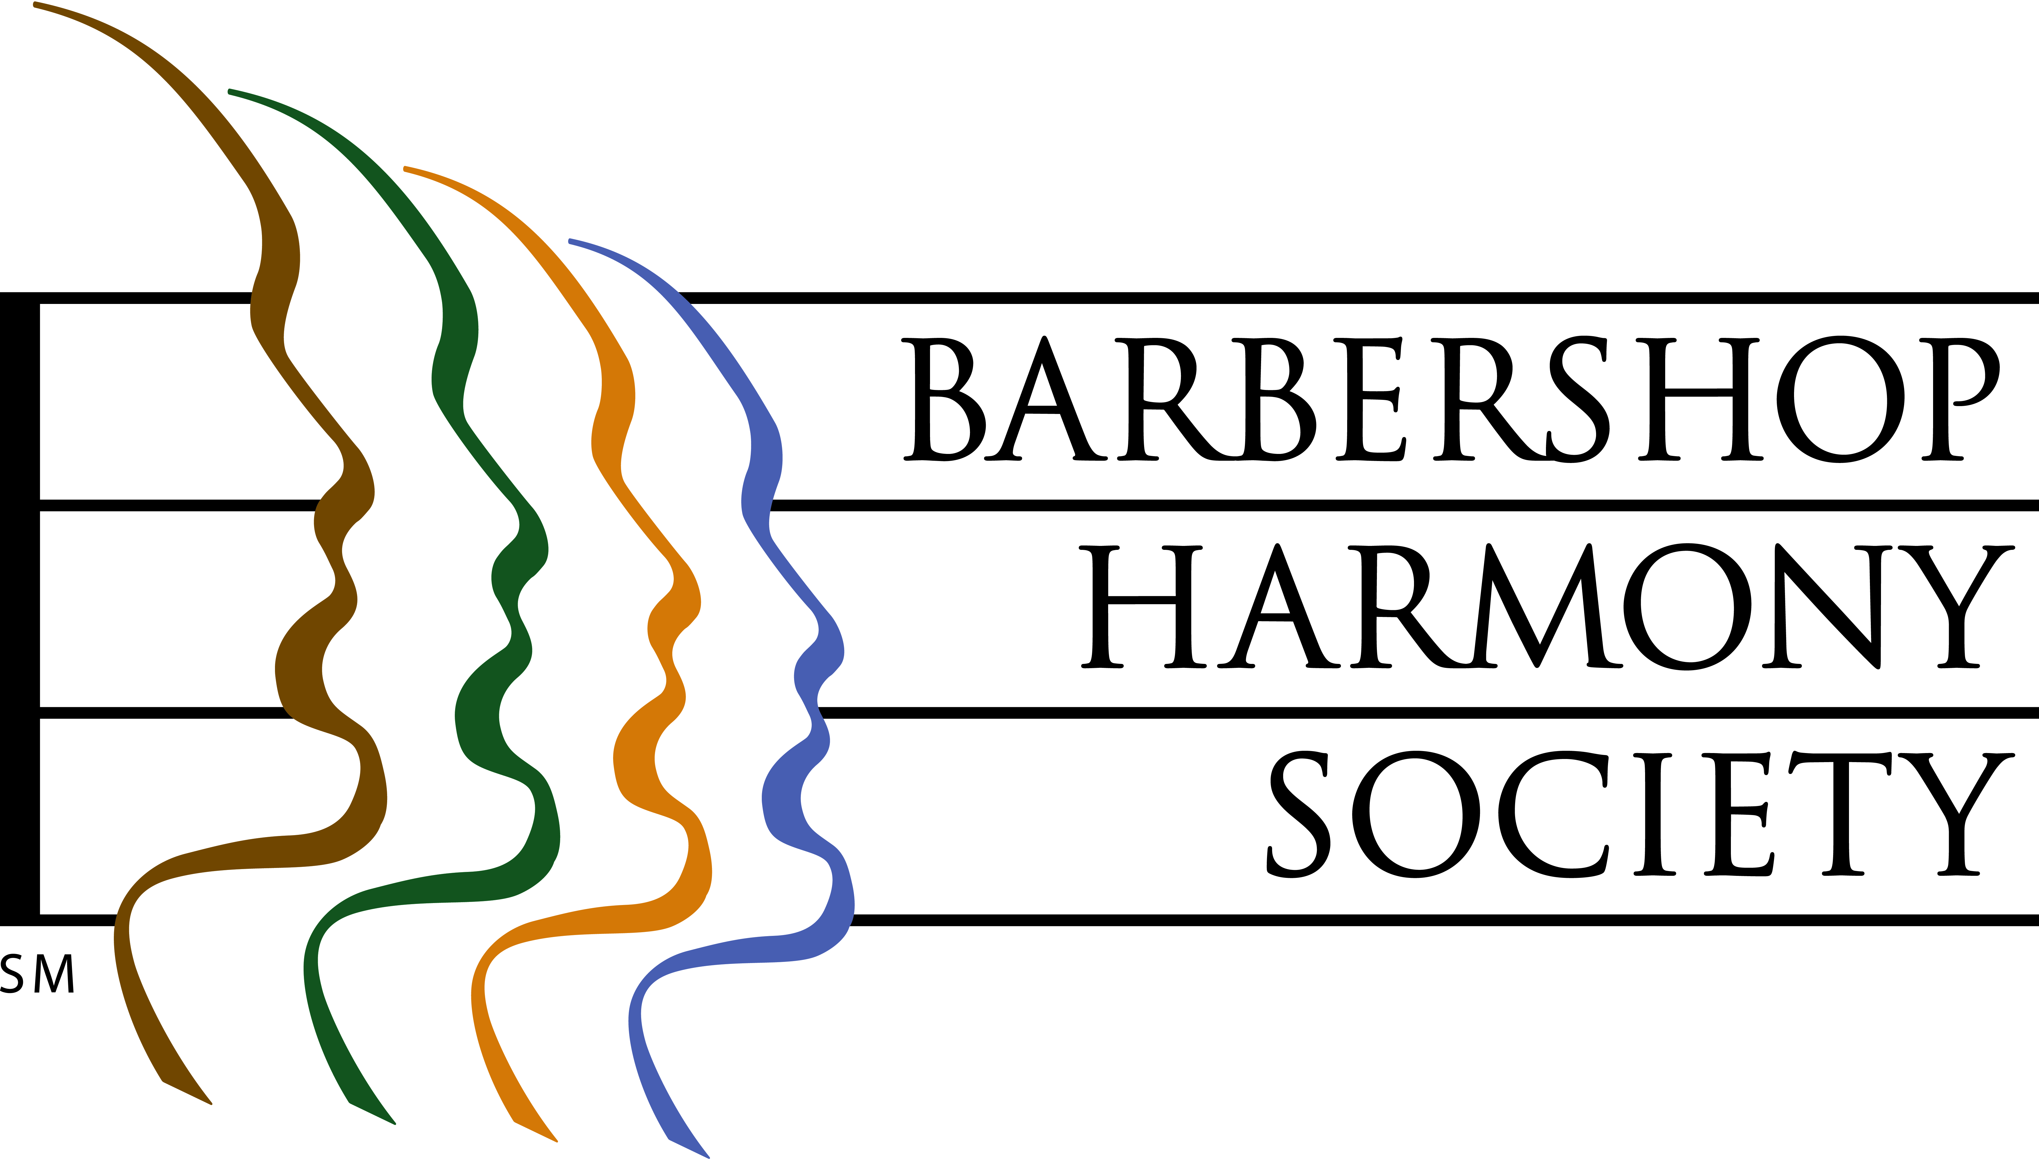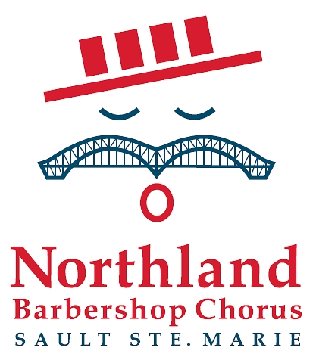
At left, the logo of the Barbershop Harmony Society, an umbrella international organization which serves 32,000+ members in 800+ chapters across North America. It granted the Sault Chapter its charter in 1961.

At right, the logo of the Sault Ste Marie Chapter of the Barbershop Harmony Society. It represents an iconic barbershop singer whose International Bridge/handlebar moustache is symbolic of our membership coming from both sides of the border. The red, white and blue colours represent the colours of the flags of both nations. The four bars in the hat represent the 4-part harmony that is the hallmark of the barbershop style, and recall the stripes of a traditional barber pole.

Barbershop singing really can trace its beginnings to American barbershops of the 1890’s through 1920’s, and their role as “tonsorial parlours”, places where men gathered to share news, camaraderie and a song or two.


Northland Barbershop Chorus 46th Annual Show, April 10, 2010
“COWBOY CHORALE”

Bob Shami: Music Director and Publicity Chairman
Home Phone: (705)-253-9574
Cell Phone: (705)-254-9368 E-mail: bshami@shaw.ca
For Ticket Information
In Canada, Doug Iles at (705)-942-3075
In US, Jim Schmidt at (906)-440-7405

