PRESS RELEASE: FOR IMMEDIATE RELEASE

NORTHLAND BARBERSHOP CHORUS
PRESENTS 45TH ANNUAL SHOW:

“A Table For Two”

The NORTHLAND BARBERSHOP CHORUS of the Sault, Ontario Chapter of the Barbershop Harmony Society – is proud to announce its 45TH annual show will be presented Sat. April 4TH, 2009 starting at 7:30 p.m. at the Kiwanis Community Theatre Centre.

BACKGROUND: Did you say: speed-dating?
The world has become a complicated place for men and women trying to meet the right person. Gone are the days when Saturday night dances at the Legion allowed men and women to meet in a socially familiar setting. It’s not that simple anymore. A modern phenomenon has emerged: speed-dating. The first speed-dating event took place at Pete’s Café in Beverly Hills in 1998 and has since grown in popularity around the world. A structured evening is arranged whereby men and women are rotated to meet each other for a series of short conversation “dates”. Each date might last only 10 min before participants are signaled to move on - time enough to discover if your date is a dud, or maybe a dream!
SHOW DETAILS:
The Northland Barbershop Chorus welcomes as special guests: the Lock Cities Chorus of Sweet Adelines – ladies hailing from both Soo’s, singing a wide variety of music in the barbershop style.
Having nearly 60 men and women on the stage together prompts us to tackle the ageless question: what do men and women really want? Chorus directors BOB SHAMI and JUDY HENDRICKSON, along with STEPHEN PATTERSON, have written an original play in which men and women have gathered at the elegant “Club D’Amour” for a night of speed-dating. A featured song is “Anything You Can Do, I Can Do Better” composed by Irving Berlin for Annie Get Your Gun. The song is a spirited duet, with the men and women attempting to out-do each other as they argue playfully about who can sing louder, higher, sweeter, or hold a note for longer. Neither, it seems, can "bake a pie".
Veteran actor CHAS CALAM brings his considerable comedic talents to bear as Gaston LeBlanc, the “Concierge of Love” - Club D’Amour’s speed-dating moderator. Former chorus member KEVIN COLLAR is bucolic dating hopeful, Floyd Gibson. Prior to leaving town to attend school, Kevin appeared regularly in local theatre productions. Tonight marks his return to the stage after a 5 year absence.
GERRY AND BONNIE FORSELL (married 45 years) play a long-married couple who visit Club D’Amour to celebrate their anniversary, unaware that it is speed-dating night. Gerry is a veteran both of past Barbershop shows and countless other theatrical productions, while Bonnie is making her stage debut tonight.
FEATURED MUSICAL PERFOMERS:
- THE NORTHLAND BARBERSHOP CHORUS: Bob Shami - Director
- THE LOCK CITIES CHORUS OF SWEET ADELINES: Judy Hendrickson - Director
- FEATURED QUARTET - THE ALLIES: From Columbus and Dayton Ohio, these men have finished 7th and 10th in the world at the past two annual International Competions sanctioned by the Barbershop Harmony Society

All Tickets: General Admission – $20.00* CDN or $17.00 US Funds, available at:
- Theatre Centre Box Office* (Station Mall) Hess Jewellers (Churchill Plaza)
- Any member of the Northland Chorus Jim Schmidt Financial Services (812 Ashmun St. Soo, Mich.)
- Tickets may also be available at the door. Doors open at 6:45 p.m. Curtain is 7:30 p.m.

* A $2.00 per ticket service charge is added by the Station Mall Box Office to all tickets they sell. Box Office total price is $20.00 + $2.00 = $22.00.

As always, a major portion of the proceeds will go to support local speech therapy programs at the Speech-Language Pathology Unit of the Sault Area Hospitals. More than $45,000 donated since 1995

“We Sing … That They Shall Speak.”
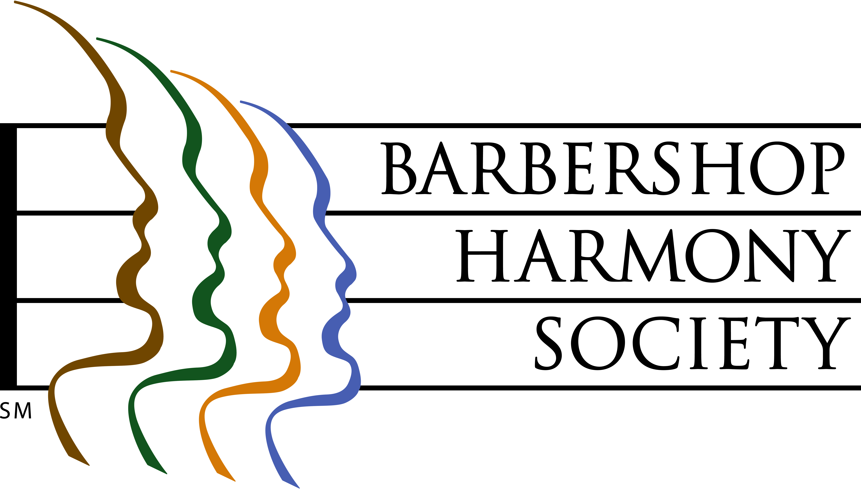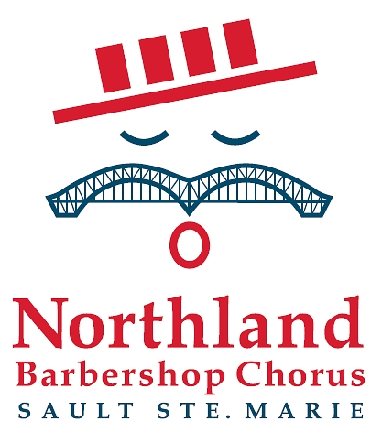
At left, the logo of the Barbershop Harmony Society, an umbrella international organization which serves 32,000+ members in 800+ chapters across North America. It granted the Sault Chapter its charter in 1961.
At right, the logo of the Sault Ste Marie Chapter of the Barbershop Harmony Society. It represents an iconic barbershop singer whose International Bridge/handlebar moustache is symbolic of our membership coming from both sides of the border. The red, white and blue colours represent the colours of the flags of both nations. The four bars in the hat represent the 4-part harmony that is the hallmark of the barbershop style, and recall the stripes of a traditional barber pole.

Barbershop singing really can trace its beginnings to American barbershops of the 1890’s through 1920’s, and their role as “tonsorial parlours”, places where men gathered to share news, camaraderie and a song or two.


Northland Barbershop Chorus April 4, 2009 Show – “A TABLE FOR TWO”
Bob Shami: Music Director and Publicity Chairman
Home Phone: (705)-253-9574 Work Fax: (519)-368-5676
Cell Phone: (416)-671-2770 Home E-mail: bshami@shaw.ca
For Ticket Information
In Canada, Doug Iles at (705)-942-3075
In US, Jim Schmidt at (906)-440-7405

