PRESS RELEASE: FOR IMMEDIATE RELEASE

NORTHLAND BARBERSHOP CHORUS PRESENTS 44TH ANNUAL SHOW:

“G.I. JUKEBOX”
MUSIC FROM THE WORLD WAR II ERA

The NORTHLAND BARBERSHOP CHORUS of the Sault, Ontario Chapter of the Barbershop Harmony Society – is proud to announce its 44TH annual show will be presented Sat. April 5TH, 2008 starting at 7:30 p.m. at the Kiwanis Community Theatre Centre.

BACKGROUND: THE USO CAMP SHOW
The Northland Chorus will present a show in the style of the USO Camp Shows that were staged at military bases and in combat areas throughout WW II.
The USO was conceived in 1941 in response to a mandate from President Franklin D. Roosevelt. The President challenged private organizations to handle the on-leave morale needs for members of the rapidly growing U.S. Armed Forces. Roosevelt’s call to action led six civilian agencies (The Salvation Army, YMCA, YWCA, National Catholic Community Services, National Travelers Aid Association and the National Jewish Welfare Board) to coordinate their civilian war efforts and resources to form a new organization – the USO or United Service Organizations - a private, non-profit organization, supported only by private citizens and corporations.
The USO could be many things to many people: a lively place to dance and meet people; a place to see movies or find religious counsel; a quiet place to talk or write letters; and, of course, a place to go for free coffee and doughnuts. For many, the USO was a conduit by which entertainment and a touch of home were brought to troops in far off areas. From 1941 to 1947, USO Camp Shows presented an amazing 428,521 performances. By 1945, USO curtains were rising 700 times a day to audiences as large as 15,000 and as small as 25 in outposts all over the world. (Source: www.uso.org)

G.I. Jukebox: A SALUTE TO BOB HOPE

Throughout World War II, more than 7,000 entertainers traveled overseas, but none was more recognized or more loved than Bob Hope. From 1941, Bob's radio shows were performed and aired from military bases throughout the USA and in theatres of war in Europe and the South Pacific. He toured constantly and tirelessly.
Through the music of Vera Lynn, Doris Day and many others, the Northland Barbershop Chorus salute Bob’s spirit in presenting a USO Camp Show similar in style to those with which he became synonymous. The music of the World War II era (1934 - 1944) is some of the best and most evocative music ever written. With great WW II era songs like “As Time Goes By”, “We’ll Meet Again”, “White Cliffs of Dover”, “Sentimental Journey” and many others, we will also pay tribute to the men and women who have served, and who continue to serve, in the armed forces.
ATTENTION: CANADIAN & U.S. Vets and ACTIVE-DUTY PERSONNEL
In tribute to veterans and active-duty service men and women from both sides of the border, the Northland Chorus is offering a special invitation to members of:
The Royal Canadian Legion Branch 25 and local branches of Canadian military units, including the 49th Field Regiment RCA in Soo, Ontario
The American Legion, Vietnam Veterans Association, National Guard, U.S. Coast Guard, Disabled Veteran’s Association and Veterans of Foreign Wars branches in Soo Michigan.
Veterans or active-duty service personnel who attend in uniform will be offered admission at half-price ($10.00 vs. $20.00). We will reserve a special section up front for these uniformed guests to watch the show with their families. (General admission seating will apply otherwise)
Please note that these special half-price tickets will NOT be available at the Box Office or at our other ticket outlets. To reserve these tickets, please make arrangements with Doug Iles at 705-942-3075; in Sault Michigan call Jim Schmidt at 906-632-3640 (Cell: 906-440-7405)
SHOW DETAILS:
FEATURING:
- THE NORTHLAND BARBERSHOP CHORUS: Under the direction of Bob Shami
- LISE WHITE AND THE AIN’T MISBEHAVIN’ ENSEMBLE: “A SPECIAL TRIBUTE TO THE ANDREWS SISTERS”: Lise and her live band bring a wealth of experience presenting countless performances in both Soo’s. Their show will be “A Tribute to The Andrews Sisters” in which they will perform many of the Andrews Sisters best known WW II era hits.
- HOT AIR BUFFOONS: From Ohio, a comedy quartet renowned both for their hilarious antics and exquisite a cappella harmony. So popular, we had to book them two years ago!

All Tickets: General Admission – $20.00* CDN or US Funds, available at:
- Theatre Centre Box Office* (Station Mall) Hess Jewellers (Churchill Plaza)
- Any member of the Northland Chorus Jim Schmidt Financial Services (812 Ashmun St. Soo, Mich.)
- Tickets may also be available at the door. Doors open at 6:45 p.m. Curtain is 7:30 p.m.

* A $2.00 per ticket service charge is added by the Station Mall Box Office to all tickets they sell. Box Office total price is $20.00 + $2.00 = $22.00.

* Special Admission price: $10.00 for vets and active-duty service personnel who attend in uniform. Call ahead to reserve these seats.

As always, a major portion of the proceeds will go to support local speech therapy programs at the Speech-Language Pathology Unit of the Sault Area Hospitals. More than $35,000 donated since 1995

“We Sing … That They Shall Speak.”
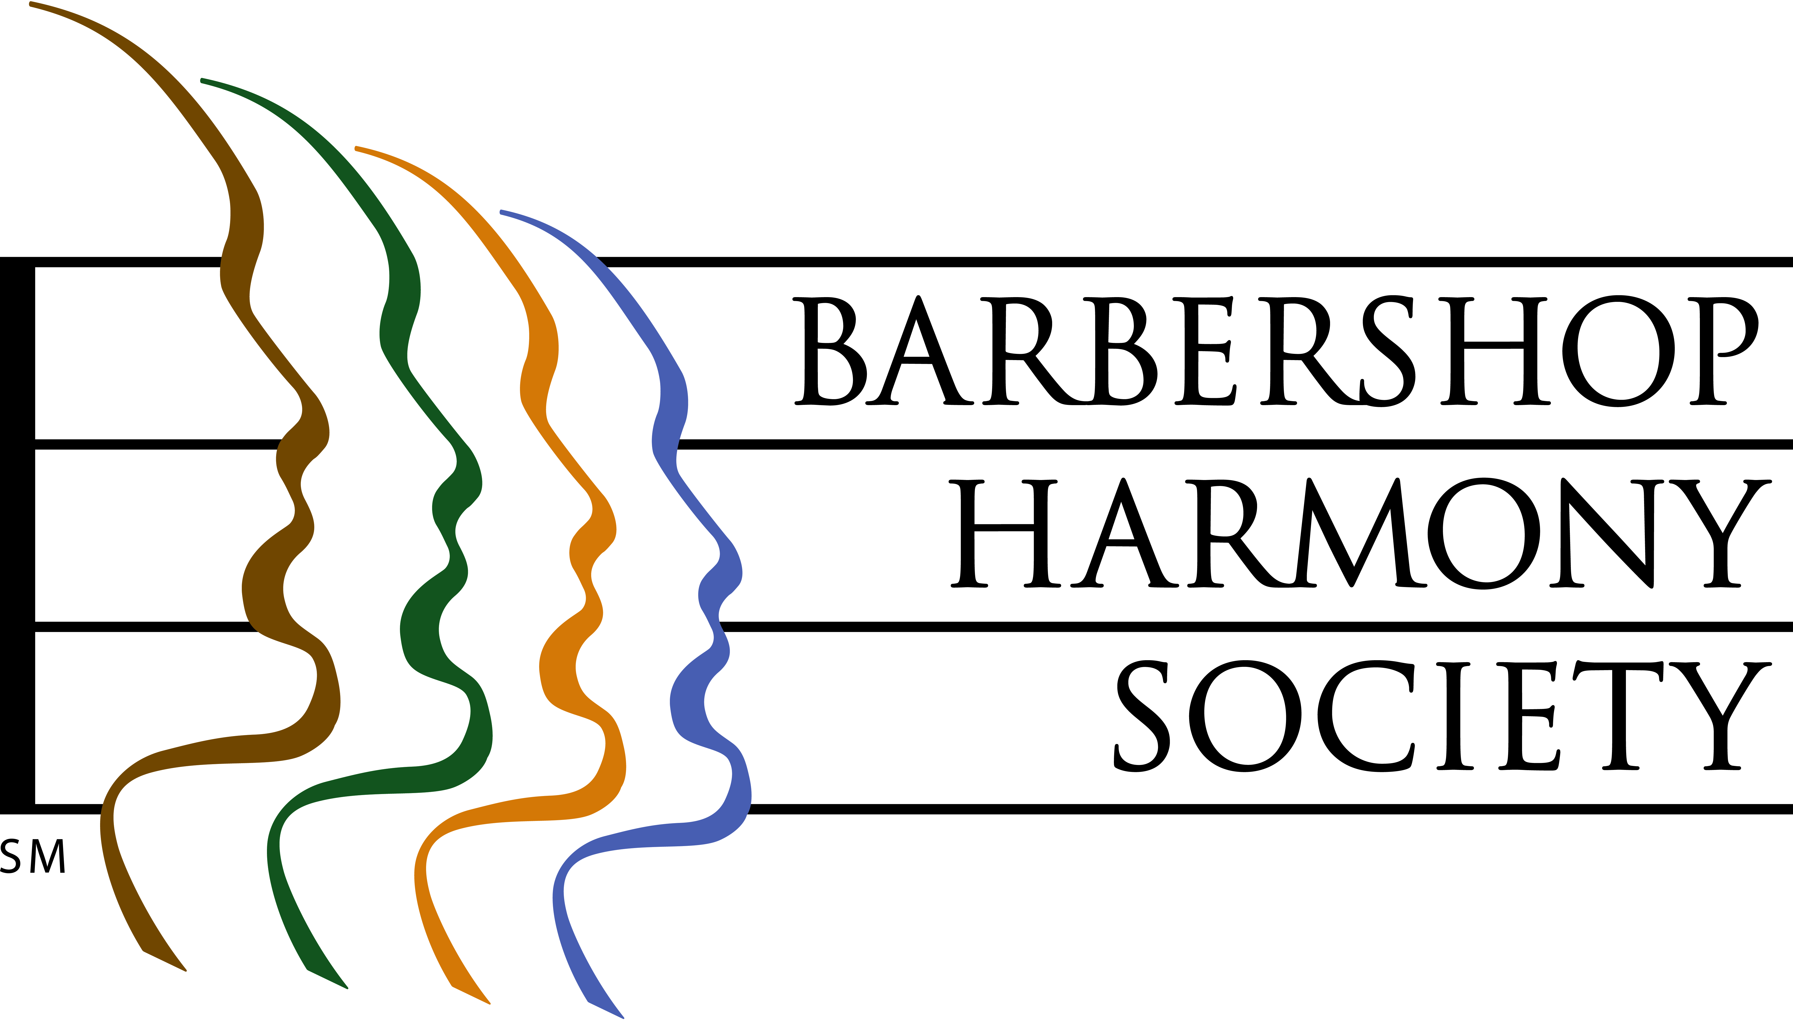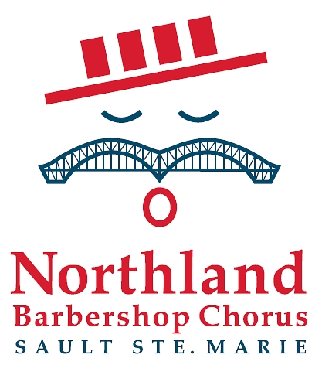

At left, the logo of the Barbershop Harmony Society, an umbrella international organization which serves 32,000+ members in 800+ chapters across North America. It granted the Sault Chapter its charter in 1961.

At right, the logo of the Sault Ste Marie Chapter of the Barbershop Harmony Society. It represents an iconic barbershop singer whose International Bridge/handlebar moustache is symbolic of our membership coming from both sides of the border. The red, white and blue colours represent the colours of the flags of both nations. The four bars in the hat represent the 4-part harmony that is the hallmark of the barbershop style, and recall the stripes of a traditional barber pole.

Barbershop singing really can trace its beginnings to American barbershops of the 1890’s through 1920’s, and their role as “tonsorial parlours”, places where men gathered to share news, camaraderie and a song or two.
For Ticket Information
In Canada, Doug Iles at (705)-942-3075
In US, Jim Schmidt at (906)-440-7405

Northland Barbershop Chorus 2008 Show – “G. I. JUKEBOX”
Bob Shami: Music Director and Publicity Chairman
Home Phone: (705)-253-9574 Work Fax: (519)-368-5676
Cell Phone: (705)-254-9368 Home E-mail: bshami@shaw.ca

