PRESS RELEASE: FOR IMMEDIATE RELEASE

NORTHLAND BARBERSHOP CHORUS OF SAULT STE MARIE TO PERFORM IN KINCARDINE

“WW II REVUE – As Time Goes By”
MUSIC FROM THE WORLD WAR II ERA

The NORTHLAND BARBERSHOP CHORUS of the Sault, Ontario Chapter of the Barbershop Harmony Society is proud to announce it will be performing a benefit concert in support of the Kincardine Legion on Sat. Nov. 8TH, 2008 starting at 7:30 p.m. at the Kincardine United Church, the Saturday before Remembrance Day.

BACKGROUND: THE USO CAMP SHOW
The Northland Chorus will present a show in the style of the USO Camp Shows that were staged at military bases and in combat areas throughout WW II.
The USO was conceived in 1941 in response to a mandate from President Franklin D. Roosevelt. The President challenged private organizations to handle the on-leave morale needs for members of the rapidly growing U.S. Armed Forces. Roosevelt’s call to action led six civilian agencies (The Salvation Army, YMCA, YWCA, National Catholic Community Services, National Travelers Aid Association and the National Jewish Welfare Board) to coordinate their civilian war efforts and resources to form a new organization – the USO or United Service Organizations - a private, non-profit organization, supported only by private citizens and corporations.
For many, the USO was a conduit by which entertainment and a touch of home were brought to troops in far off areas. From 1941 to 1947, USO Camp Shows presented an amazing 428,521 performances. By 1945, USO curtains were rising 700 times a day to audiences as large as 15,000 and as small as 25 in outposts all over the world. (Source: www.uso.org)

WW II REVUE: A SALUTE TO BOB HOPE

Throughout World War II, more than 7,000 entertainers traveled overseas, but none was more recognized or more loved than Bob Hope. From 1941, Bob's radio shows were performed and aired from military bases throughout the USA and in theatres of war in Europe and the South Pacific. He toured constantly and tirelessly.
Through the music of Vera Lynn, Doris Day and many others, the Northland Barbershop Chorus salute Bob’s spirit in presenting a USO Camp Show similar in style to those with which he became synonymous. The music of the World War II era (1934 - 1944) is some of the best and most evocative music ever written. With great WW II era songs like “As Time Goes By”, “We’ll Meet Again”, “White Cliffs of Dover”, “Sentimental Journey” and many others, we will also pay tribute to the men and women who have served, and who continue to serve, in the armed forces.
SHOW DETAILS:
FEATURING:
- THE NORTHLAND BARBERSHOP CHORUS: Under the direction of Bob Shami. An a cappella Chorus with 43 members, it received its charter as the Sault Ste Marie Chapter of The Barbershop Harmony Society in 1961. Bob came to the area in November 2006 as Brewmaster for Steelback Brewery of Tiverton, and now works as Steelback’s Plant Manager and Director of Brewing. Bob splits his time between Tiverton and his home in the Sault where he resides with wife Anne-Marie and son Nathan. He’s been a member of the Chorus since 1982, its Music Director since 1991.
- THE HOWLIN’ DOG VINTAGE JAZZ BAND: The band was formed in 2002 by a group of a few members of the Lighthouse Swing Band along with some friends mostly from the Kincardine area. The frontline is made up of Dave Jewett who hails from Burlington (and Inverhuron) on trumpet and flugelhorn, Steve Hasbury on clarinet and saxes and Dave Schmalz on trombone. Rhythm comes from Ron Daniels of Goderich on guitar, Karen Weber on bass and Mike Kelley on drums. Karen Weber and Dave Schmalz look after vocals. Based in Kincardine the group performs jazz, blues, swing and more up and down the Lake Huron shoreline from Sarnia to Collingwood and all through Southern Ontario.
- SPECIAL TRIBUTE TO BOB HOPE: No USO-style show would be complete without including material made famous by the man most associated with entertaining service personnel. We are pleased to present as part of our show, a tribute to Bob Hope by John Adams, a Kincardine actor with professional acting credentials. John will be performing material taken from Mr. Hope’s archives.

All Tickets: General Admission – $20.00 and are available at:
- Jerome Flowers and Gifts, Kincardine Quinn Florists, Kincardine
- The Kincardine Legion King’s Pearl Pub, Tiverton
- Legion Ticket Co-Chairs: Emma Greco (519-396-1933) or Barb Wilkinson (519-396-1318)
- Tickets may also be available at the door. Doors open at 6:45 p.m. Curtain is 7:30 p.m.

This show was made possible only through the generosity of:

STEELBACK BREWERY

100% of gate receipts will go directly to Kincardine’s Royal Canadian Legion MacDonald Branch 183 and will stay in the community in support of their many community projects.
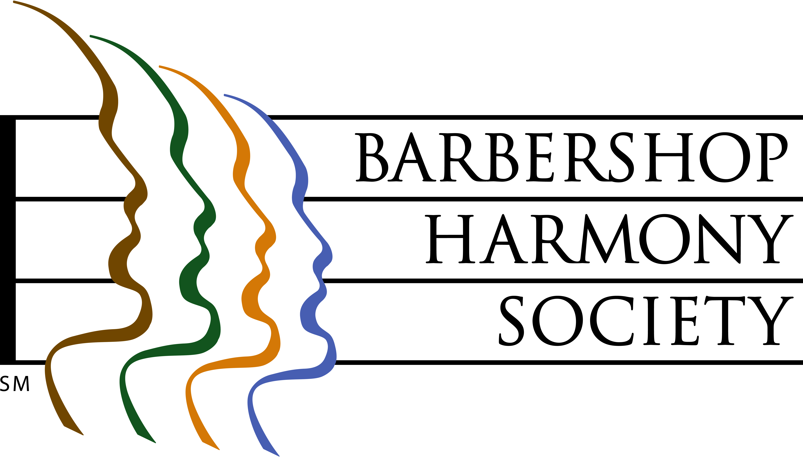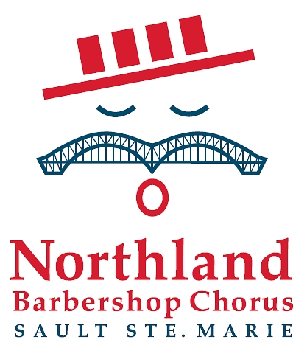

At left, the logo of the Barbershop Harmony Society, an umbrella international organization which serves 32,000+ members in 800+ chapters across North America. It granted the Sault Chapter its charter in 1961.

At right, the logo of the Sault Ste Marie Chapter of the Barbershop Harmony Society. It represents an iconic barbershop singer whose International Bridge/handlebar moustache is symbolic of our membership coming from the twin cities of Sault Ste Marie Michigan and Ontario. The twin spans of the International Bridge are a local landmark familiar to residents of both cities. The red, white and blue colours represent the colours of the flags of both nations. The four bars in the hat represent the 4-part harmony that is the hallmark of the barbershop style, and recall the stripes of a traditional barber pole.

Barbershop singing really can trace its beginnings to American barbershops of the 1890’s through 1920’s, and their role as “tonsorial parlours”, places where men gathered to share news, camaraderie and a song or two.
For Ticket Information
Barb Wilkinson - (519)-396-1318
Emma Greco - (519)-396-1933

Northland Barbershop Chorus Nov. 8, 2008 Show – “WW II REVUE”
Bob Shami: Music Director and Publicity Chairman
Home Phone: (705)-253-9574 Work Phone: (519)-368-5676
Cell Phone: (416)-671-2770 Work E-mail: bshami@steelbackbrewery.com
Home E-mail: bshami@shaw.ca

