PRESS RELEASE: FOR IMMEDIATE RELEASE

NORTHLAND BARBERSHOP CHORUS PRESENTS 42nd ANNUAL SHOW:

“TURN YOUR RADIO ON”

It’s Barbershop Show time! The NORTHLAND BARBERSHOP CHORUS of the Sault, Ontario Chapter of
THE BARBERSHOP HARMONY SOCIETY - is proud to announce their 42nd ANNUAL SHOW will be presented Saturday, April 8TH, 2006 starting at 8:00 p.m. at the Kiwanis Community Theatre Centre entitled:
“TURN YOUR RADIO ON”
BACKGROUND:
It’s a match made in heaven! This year’s show is a unique collaboration between the Northland Barbershop Chorus and The Old Tyme Radio Players. These local groups, each of whom perform material originally popular in the 30’s, 40’s and 50’s, will present an authentic radio episode of “Father Knows Best?” (ok, we admit there probably wasn’t a Barbershop Chorus in the original). Using the original script, they will recreate the show’s very first episode, which aired as an audition or “pilot” in Dec. of 1948. With Robert Young in the starring role, “Father Knows Best?” was a hit, airing on NBC radio from 1949 until it moved to TV in 1954.

“Father Knows Best” was the classic, wholesome family situation comedy. It was set in the typical small town of Springfield, where Jim Anderson was an agent for the General Insurance Company. Every evening he would come home from work, take off his sport jacket, put on his comfortable sweater, and deal with the everyday problems of a growing family. In contrast to most other family comedies of the period, both Jim and Margaret were portrayed as thoughtful, responsible adults as they helped their children weather the storms of growing up. When a family crisis arose, Jim was usually ready with a warm smile and some sensible advice.

In the radio version, the title of the show ended with a question mark, suggesting that father's role as family leader and arbiter was dubious, that perhaps father didn't always know best. Jim in fact did make mistakes and occasionally lost his temper. Sometimes, as in tonight’s episode, father knew best when it suited mother! Wife Margaret was nobody's fool, doing her fair share to reconcile problems, while often besting her husband.

Robert Young was the only member of the radio cast to make the transition to TV in Oct. of 1954. A total of 203 TV episodes were aired, the last one on May 23, 1960. The series was so popular that repeats continued to be shown in primetime for another three years after production ceased – ending an impressive 15-year run.

HEADLINE PERFORMERS:
- THE OLD TYME RADIO PLAYERS - The Old Tyme Radio Players troupe was formed in 2003 and performs original programs from the golden age of radio. In its heyday of the 30's and 40's, radio was as popular as TV is today. The cast is a blend of local radio personalities from past and present combined with well-known actors from local theatre.

- WEBBSURROUND - a father/daughter/son trio who have entertained audiences locally as well as across the province. Claryssa Webb (aged 13), sings like an angel and studies 4 instruments, musical theory, and senior orchestra at the Algoma Conservatory. Claryssa's younger brother Todd plays violin, piano and guitar...just your typical six-year old! He is following in his sister's footsteps by playing violin in the Intermediate Orchestra at the Algoma Conservatory. Their father, Bill, certainly no stranger to the stage, is also a multi-instrumentalist who has directed, performed with, and arranged music for the Northland Chorus. He has been cast in several Musical Comedy Guild productions, most recently as the “Beast” in last fall’s production of “Beauty and the Beast”. Their musical styles include Celtic, Traditional, Soft-rock, Showtunes, Country, Spiritual and Classical.
- STERLING – from San Antonio Texas, Sterling formed in 1995 and is one of the Barbershop Harmony Society’s rising star quartets. They enjoy performing an exciting combination of dynamic up tunes, finger-snapping swing tunes, touching ballads and spirit lifting gospel. An energetic foursome who have performed throughout the United States, Canada and Finland, they are 2003/2004/2005 Barbershop Harmony Society International Quartet Semi-Finalists. Last month, Sterling again qualified for the 2006 International Quartet Competition being held in Indianapolis this July.
- THE NORTHLAND BARBERSHOP CHORUS: singing a wide variety of songs under the direction of Bob Shami, the Chorus has been home for fellas who like to sing a cappella since 1961.

All Tickets are $20.00 CDN – ($22.00* at the Mall Box Office) General Admission -- available at:
- Theatre Centre Box Office (Station Mall) Hess Jewellers (Churchill Plaza)
- Any member of the Northland Chorus Jim Schmidt Financial Services (812 Ashmun St. Soo, Mich.)
- Tickets may also be available at the door on the night of the performance. Doors open at 7:15 p.m.

* A $2.00 per ticket service charge is added by the Station Mall Box Office to all tickets they sell. Box Office total price is $20.00 + $2.00 = $22.00. Total price if purchased at other vendors noted above is $20.00.

As always, a major portion of the proceeds will go to support local speech therapy programs at the Speech and Language Pathology Unit of the Sault Area Hospitals. “We Sing … That They Shall Speak.”
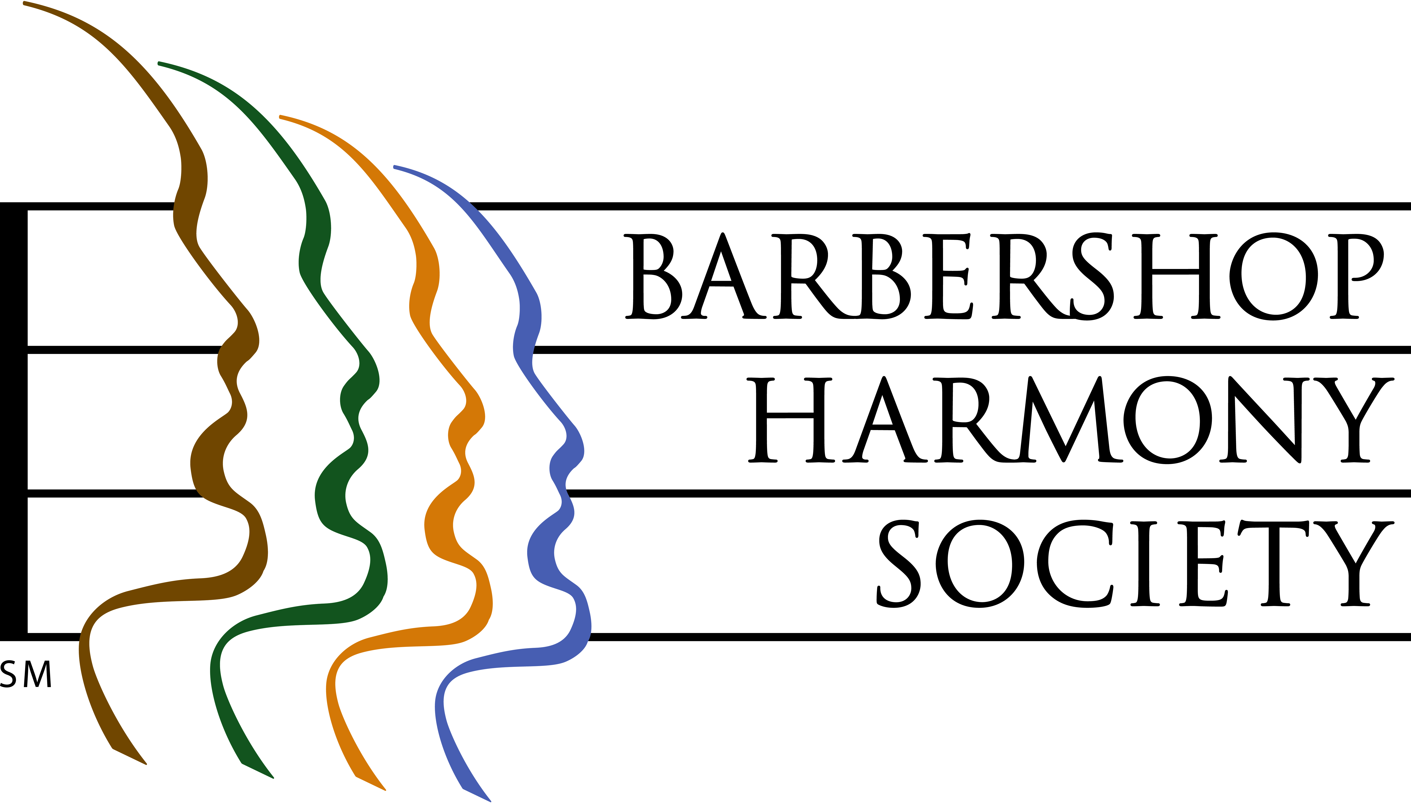

Northland Barbershop Chorus 2006 Show – “Turn Your Radio On”
For Ticket Information Call Doug Iles
(705)-942-3075
Bob Shami: Music Director and Publicity Chairman
Home Phone: (705)-253-9574 Work Fax: (705)-254-4482
Work Phone: (705)-254-7373 E-mail: bshami@shaw.ca

